**EXPERIMENT-19**

**MICROSOFT AZURE**

**Demonstrate Storage as a Service (SaaS) create and configure a new VM Image in any Public Cloud Service Provider.**

STEP-1: GO TO THE CREATE AND CLICK THE AZURE VIRTUAL MACHINE.

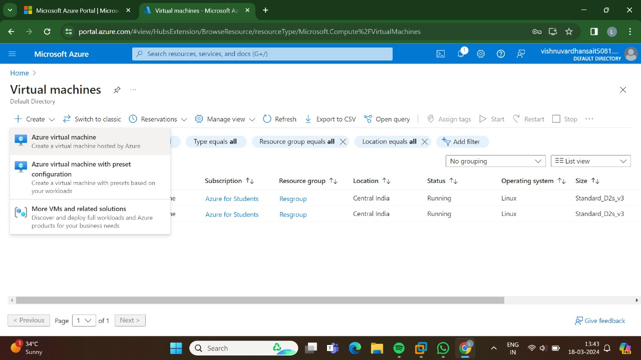

STEP-2: GO TO THE BASICS.

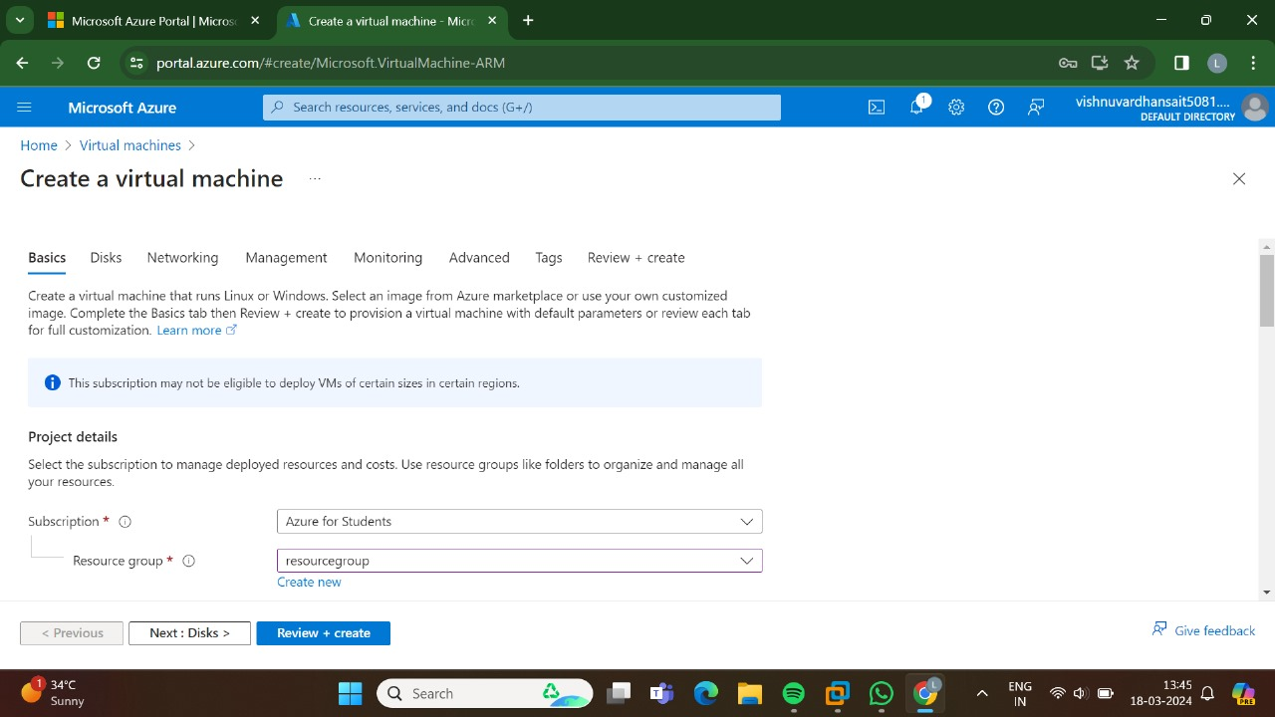

STEP-3:GO TO THE DISKS.

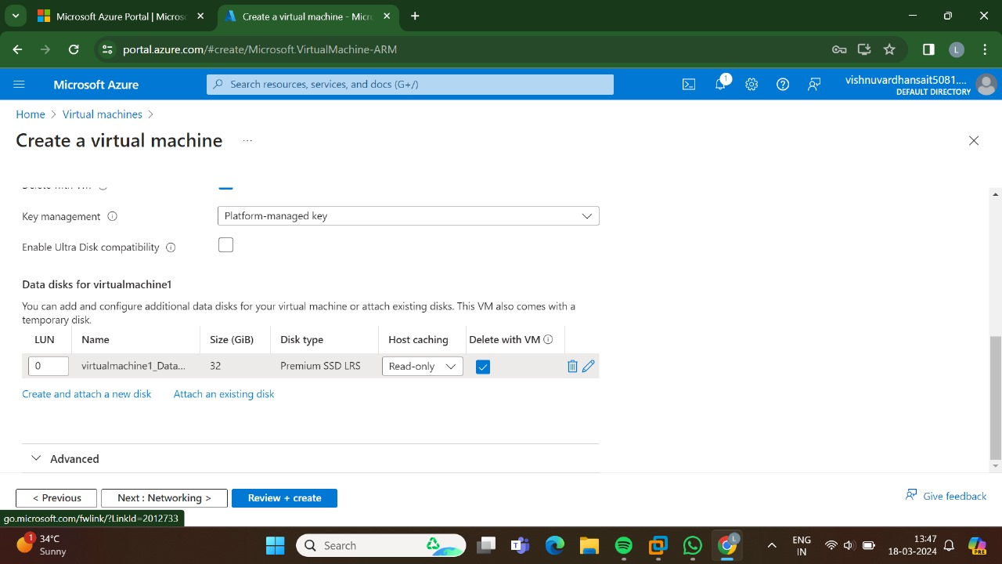

STEP-4:GO TO THE NETWORKING.

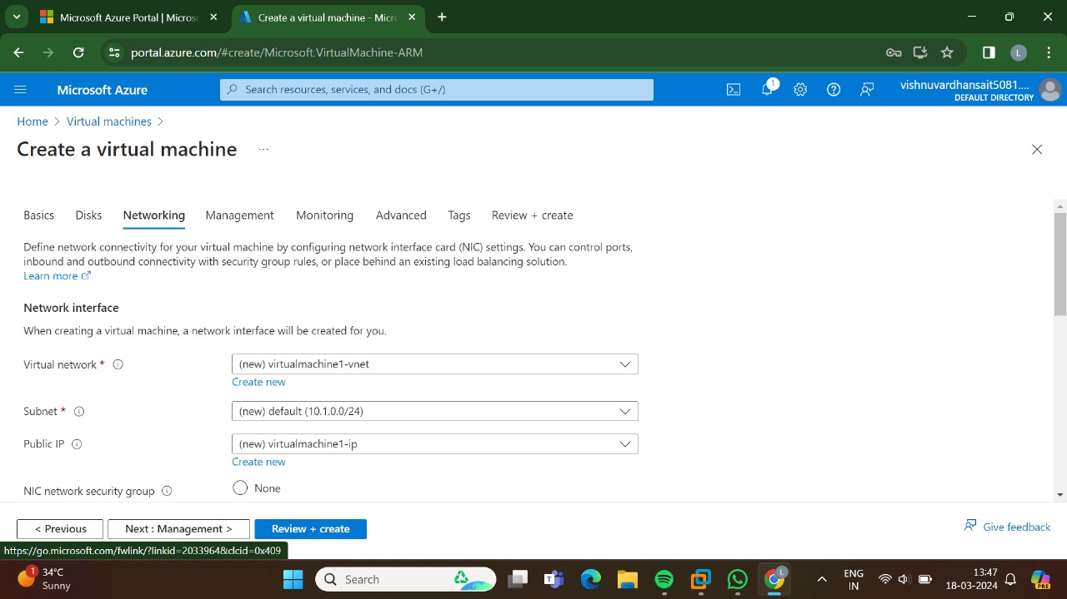

STEP-5:GO TO THE MANAGEMENT.

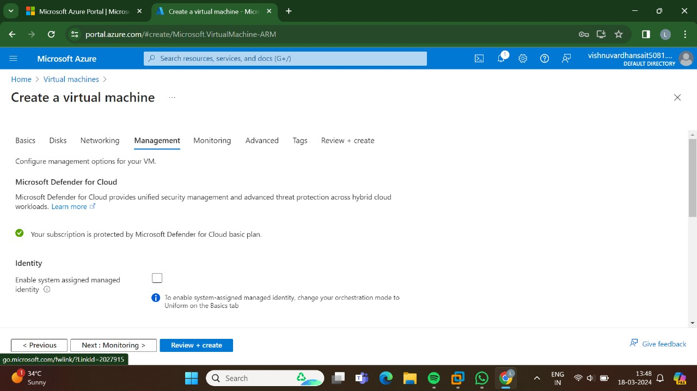

STEP-6:AND, THEN GO FOR THE MONITORING.

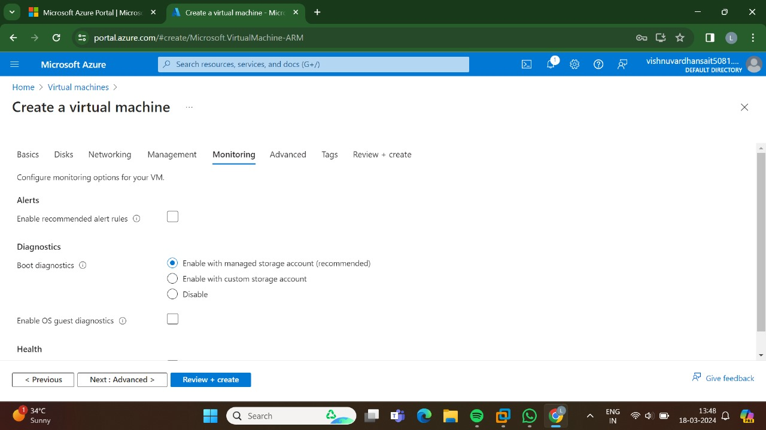

STEP-7:GO FOR THE ADVANCED.

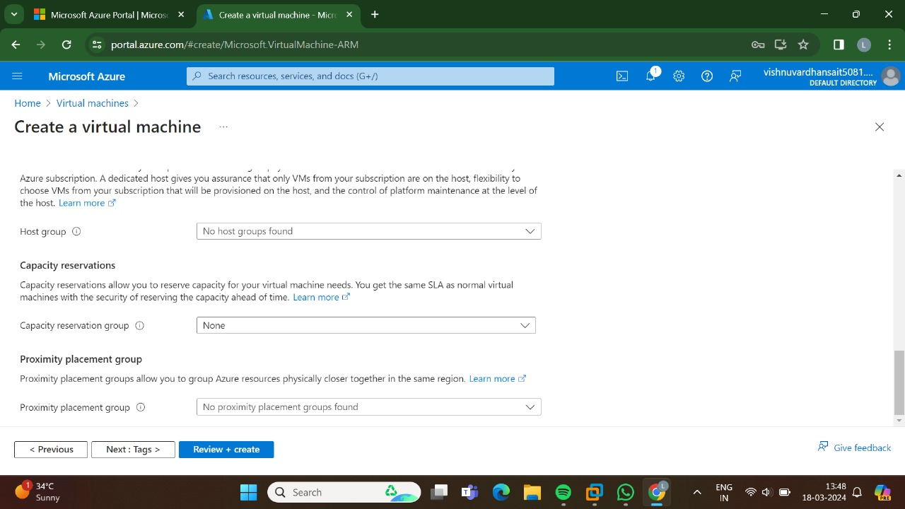

STEP-8: GO, FOR THE TAGS.

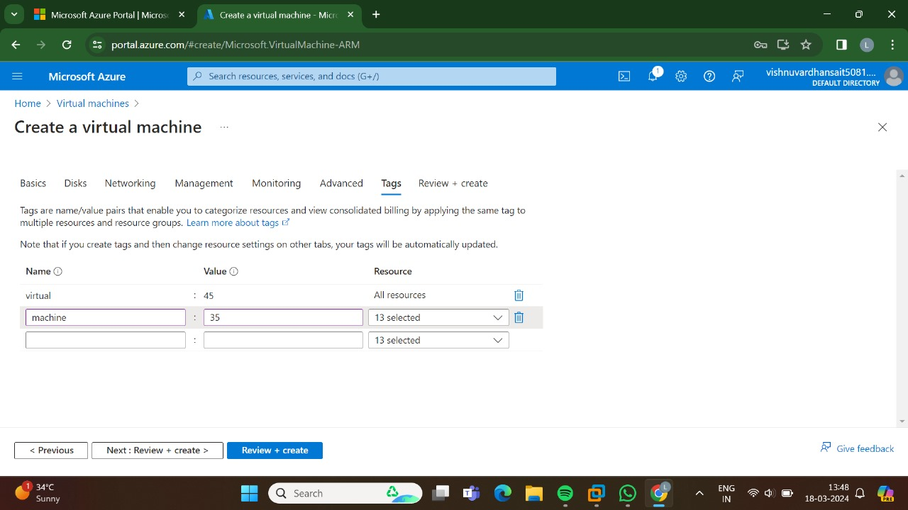

STEP-:GO FOR THE REVIEW + CREATE AND THEN CLICK CREATE.

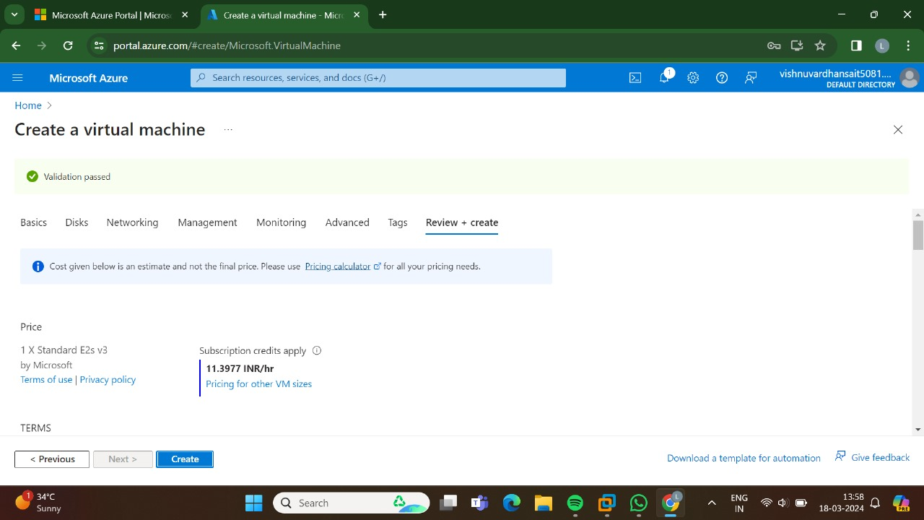

STEP-10:THUS,THE DEPLOYMENT IS IN PROGRESS.

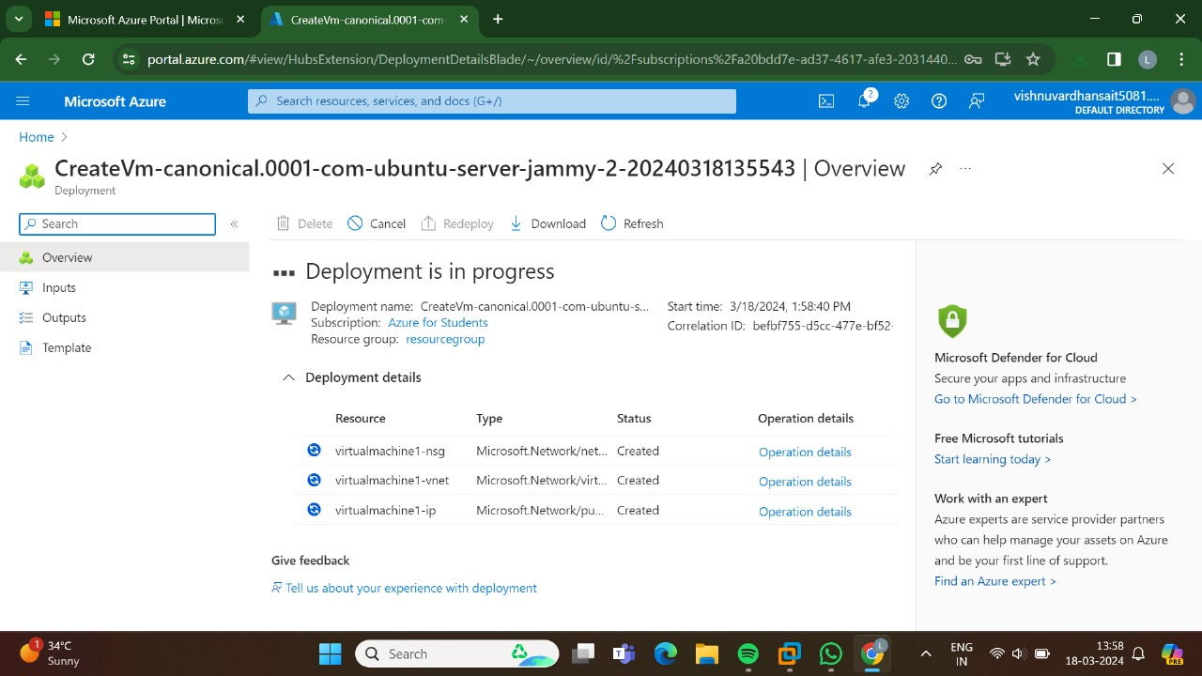

STEP-11:THUS, THE DEPLOYMENT HAS BEEN DONE SUCCESSFULLY.

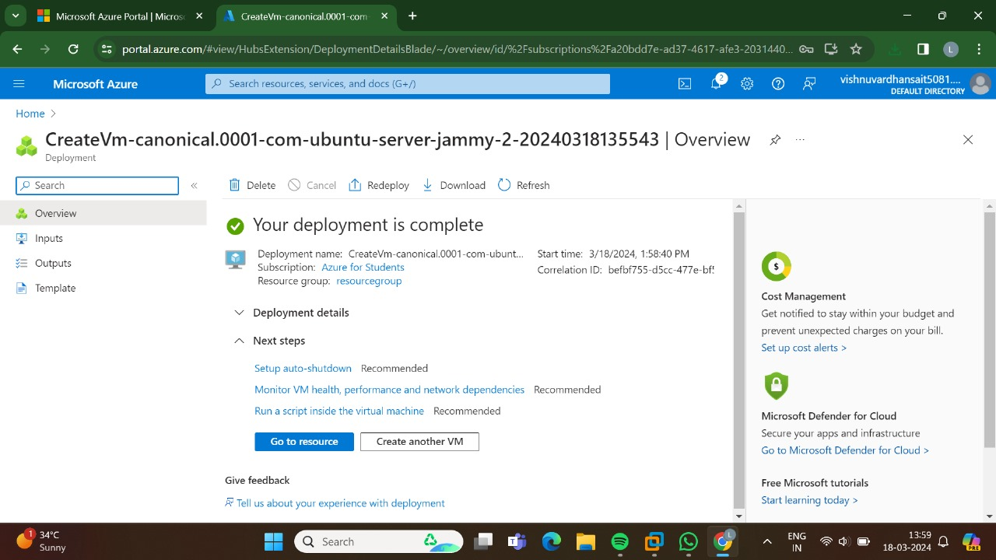

RESULT: THUS, THE PROGRAM HAS BEEN EXECUTED SUCCESSFULLY.